**Spike:** Week 8

**Title:** Building an Engine from Source

**Author:** Liam Whitehouse, 103862481

**Goals / deliverables:**

The goal of this report is to demonstrate how to setup, generate and build the Game Engine from its source code.

**Technologies, Tools, and Resources used:**

The tools used to perform this task were:

* Github.
* PowerShell.
* Visual Studios 2022.
* Unreal Engine Website.

**Tasks undertaken:**

To build the Engine from its source, first I had to connect my Github account to my Unreal Engine account. This allowed me to get access to the Unreal Engine repository that holds all versions of the Game Engine.

**What we found out:**

This takes a very long time to download, build and execute. After downloading the source code, you need to checkout the engine version you want to use, this downloads all the dependencies that is required for the engine. Once that is done, you need to run a GenerateProjectFile.bat to generate the dependencies and libraries, then finally you need to run Setup.bat which generates a solution that allows you to open the code of the Engine. This takes a very long time, depending on your system it can take 2 hours (for me it took 3).

Once opened in Visual Studios, you will need to build the Unreal Engine Project in the solution, now this will take a very long time (upwards of 4 hours for myself). This builds the entire engine for you and builds out the executable for running the editor which allows you to create any project.

The below images are the final product of it working:

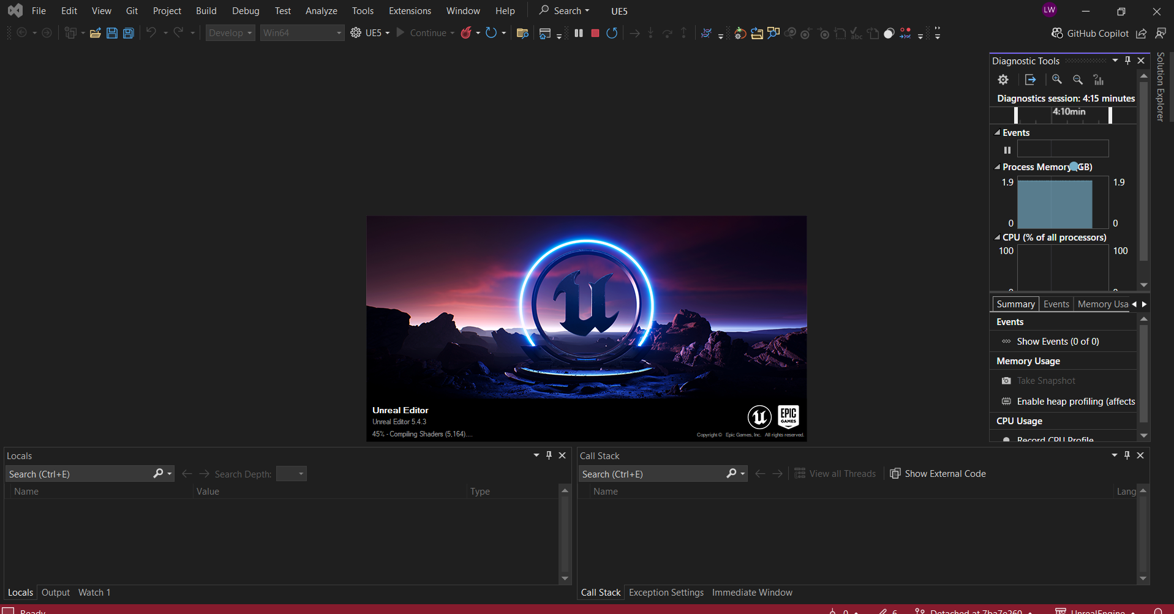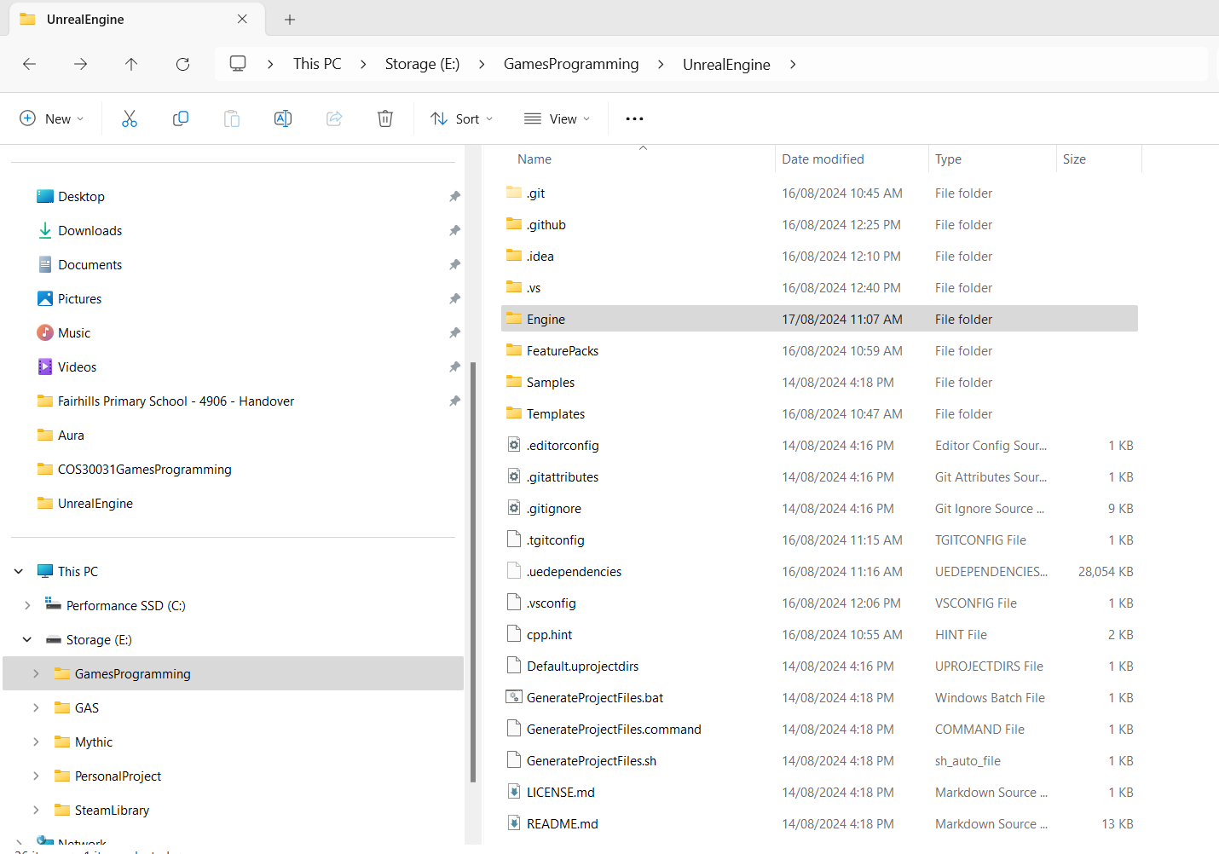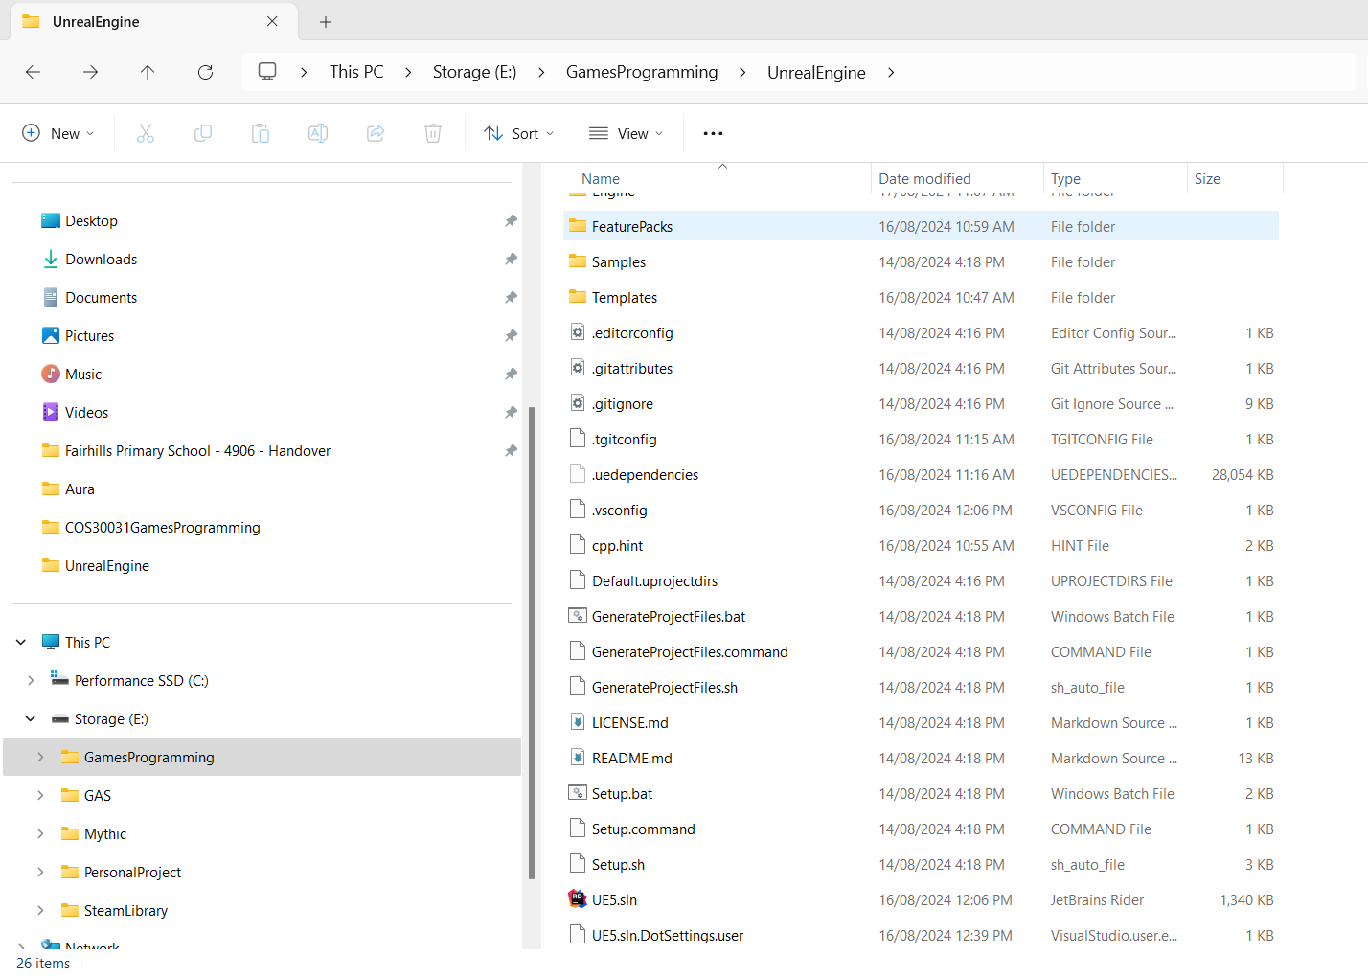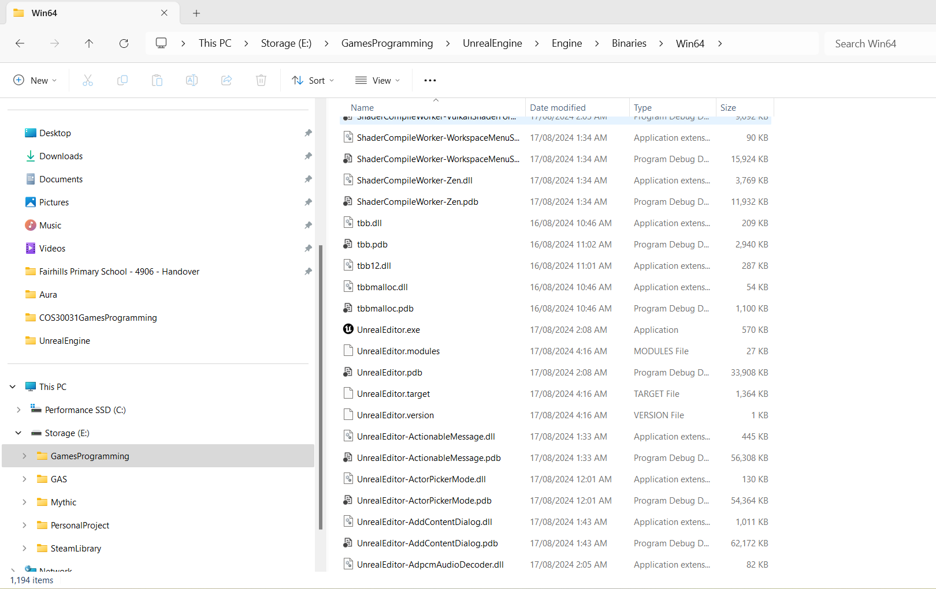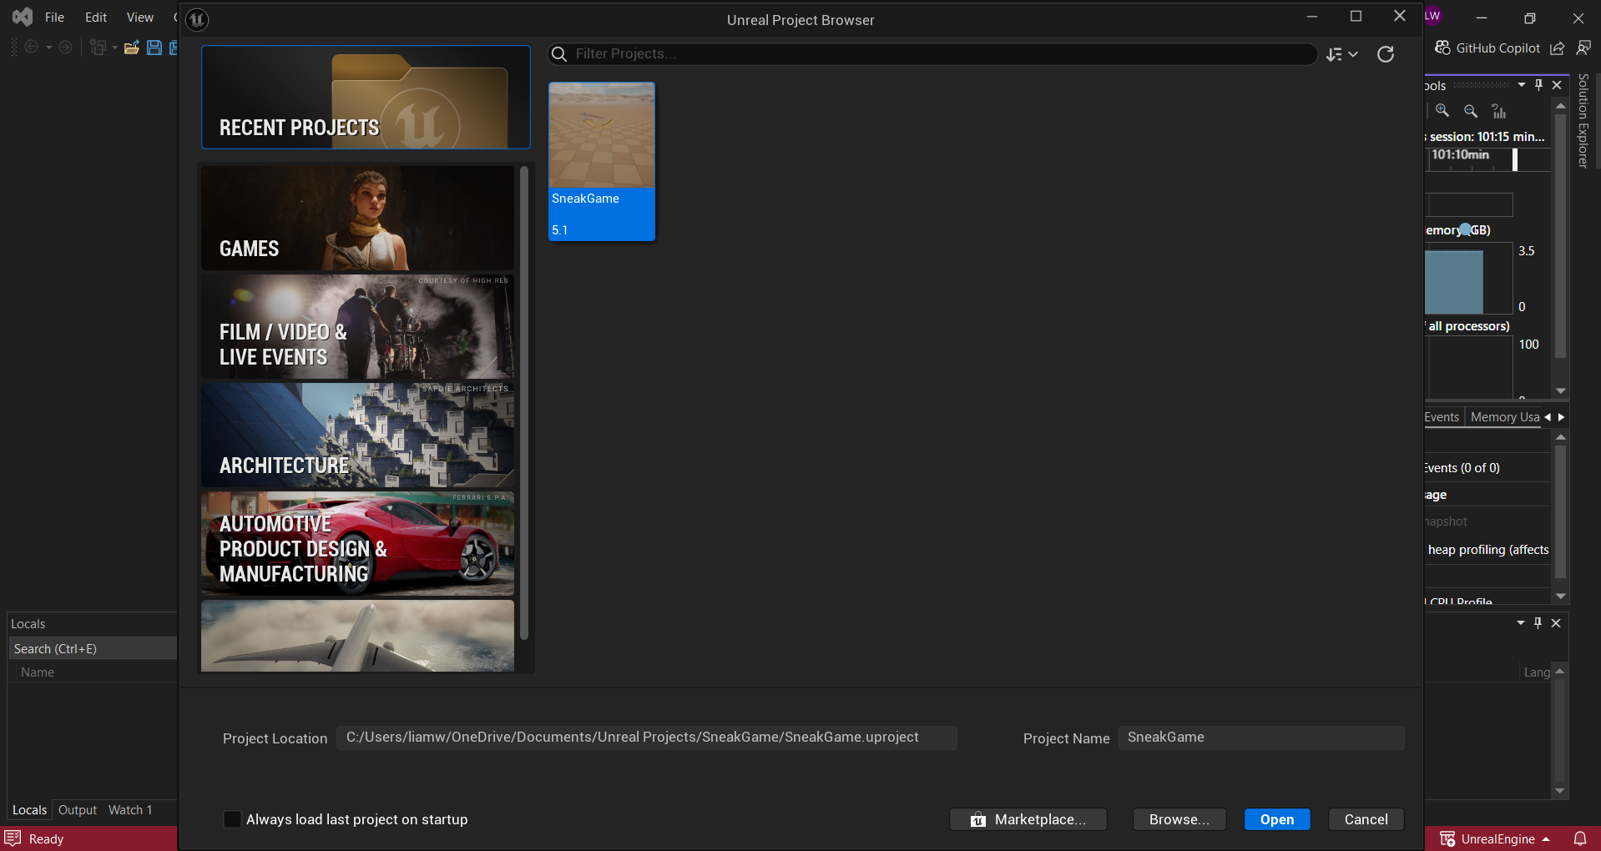

**Open issues/risks** [Optional – **remove** heading/section if not used!]**:**

Doing this comes with a large array of problems, mainly to do with the version of Visual Studios you are using and the plugins you have installed for it.

You need to make sure to have Visual Studios 2022 installed and up to date, and you need to have the Linux and C++ plugin installed as well as the correct MVSC installed in your Visual Studios for this to work. You will not find this out until after its failed building after 2 hours!

**Recommendations** [Optional – **remove** heading/section if not used!]**:**

Here is a link of useful websites that helped me achieve this goal:

Unreal Engines official webpage that takes you through a step-by-step guide on how to connect your Github to Unreal.

* <https://www.unrealengine.com/en-US/ue-on-github>

Unreal Engines documentation on how to download the engine source.

* <https://dev.epicgames.com/documentation/en-us/unreal-engine/downloading-unreal-engine-source-code>

YouTube as well!